- Given two numbers, write a C program to swap the given numbers.

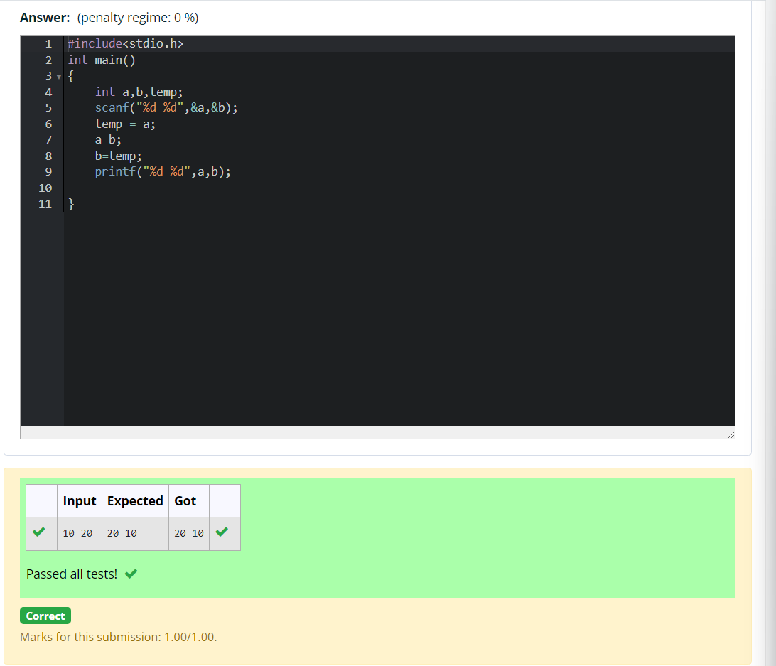

2 ) Write a C program to find the eligibility of admission for a professional course based on the following criteria.
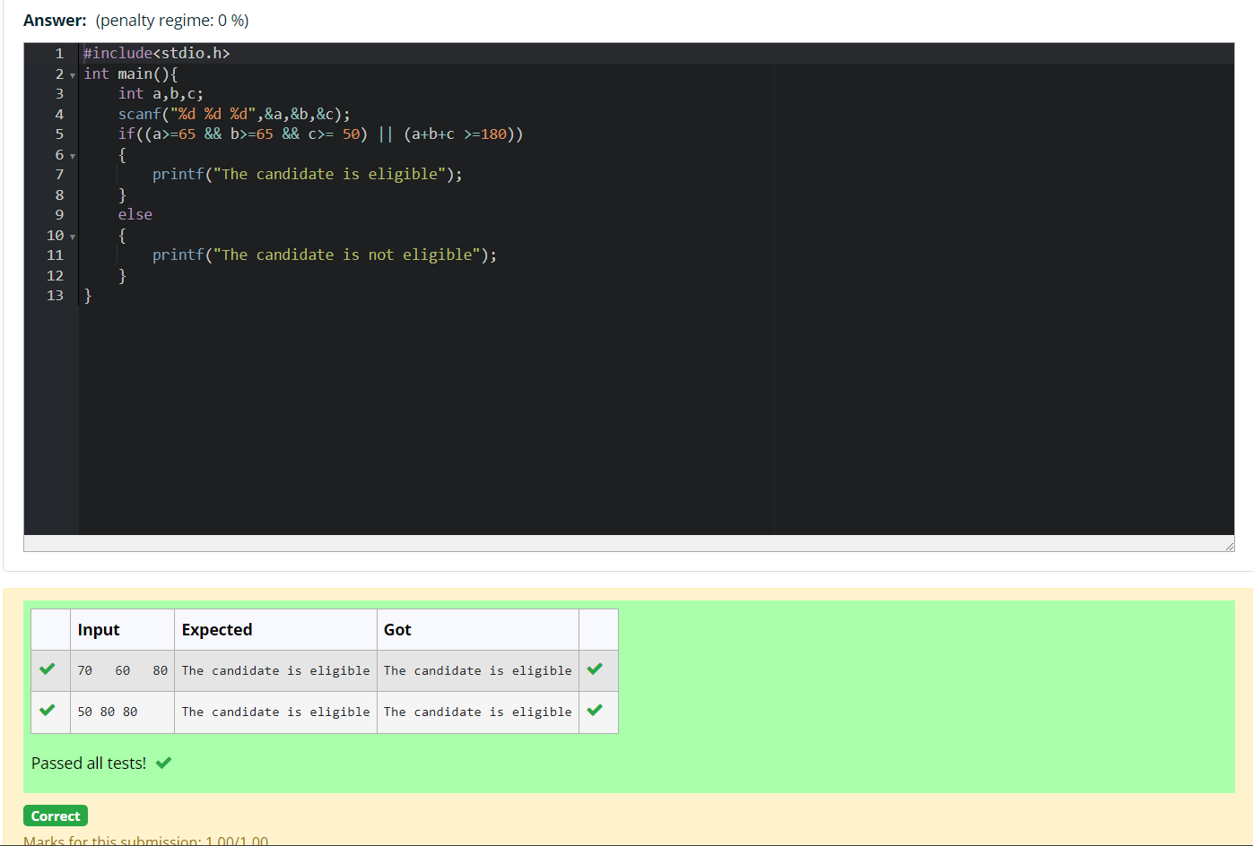
- Malini goes to BestSave hyper market to buy grocery items. BestSave hyper market provides 10% discount on the bill amount B when ever the bill amount B is more than Rs.2000. The bill amount B is passed as the input to the program. The program must print the final amount A payable by Malini.

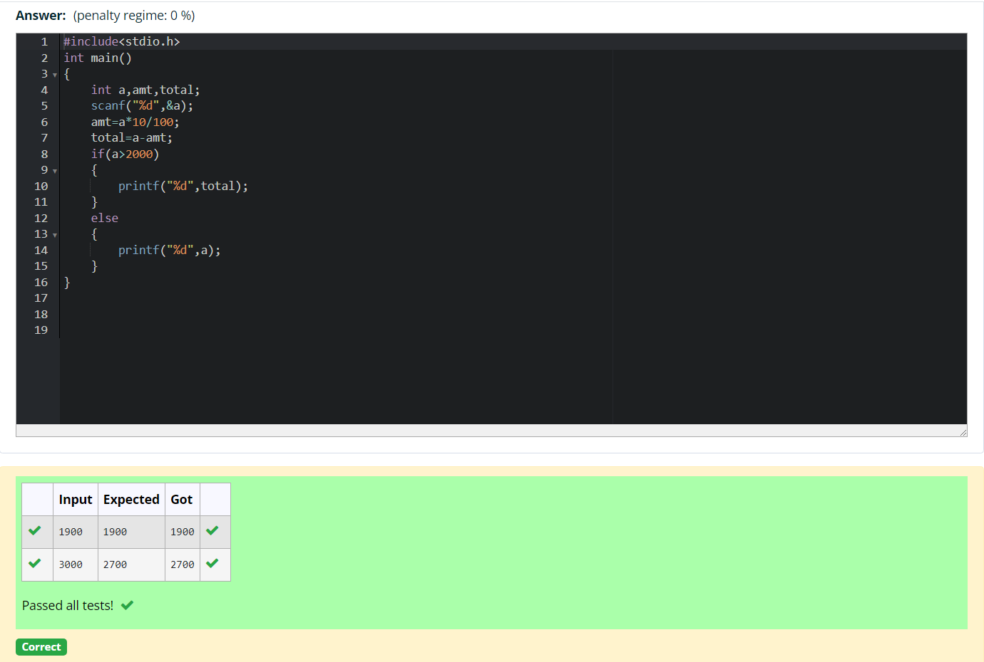

- Baba is very kind to beggars and every day Baba donates half of the amount he has when ever a beggar requests him. The money M left in Baba's hand is passed as the input and the number of beggars B who received the alms are passed as the input. The program must print the money Baba had in the beginning of the day.
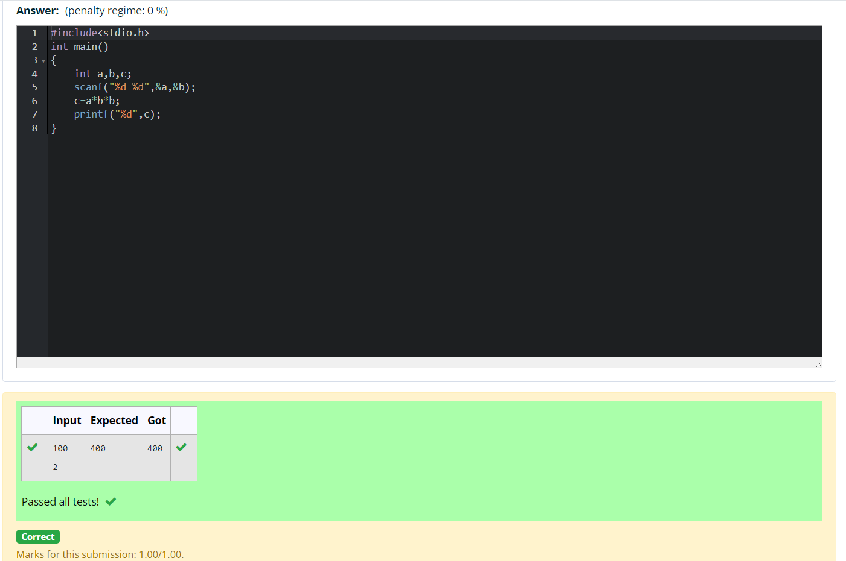
- The CEO of company ABC Inc wanted to encourage the employees coming on time to the office. So he announced that for every consecutive day an employee comes on time in a week (starting from Monday to Saturday), he will be awarded Rs.200 more than the previous day as "Punctuality Incentive". The incentive I for the starting day (ie on Monday) is passed as the input to the program. The number of days N an employee came on time consecutively starting from Monday is also passed as the input. The program must calculate and print the "Punctuality Incentive" P of the employee.

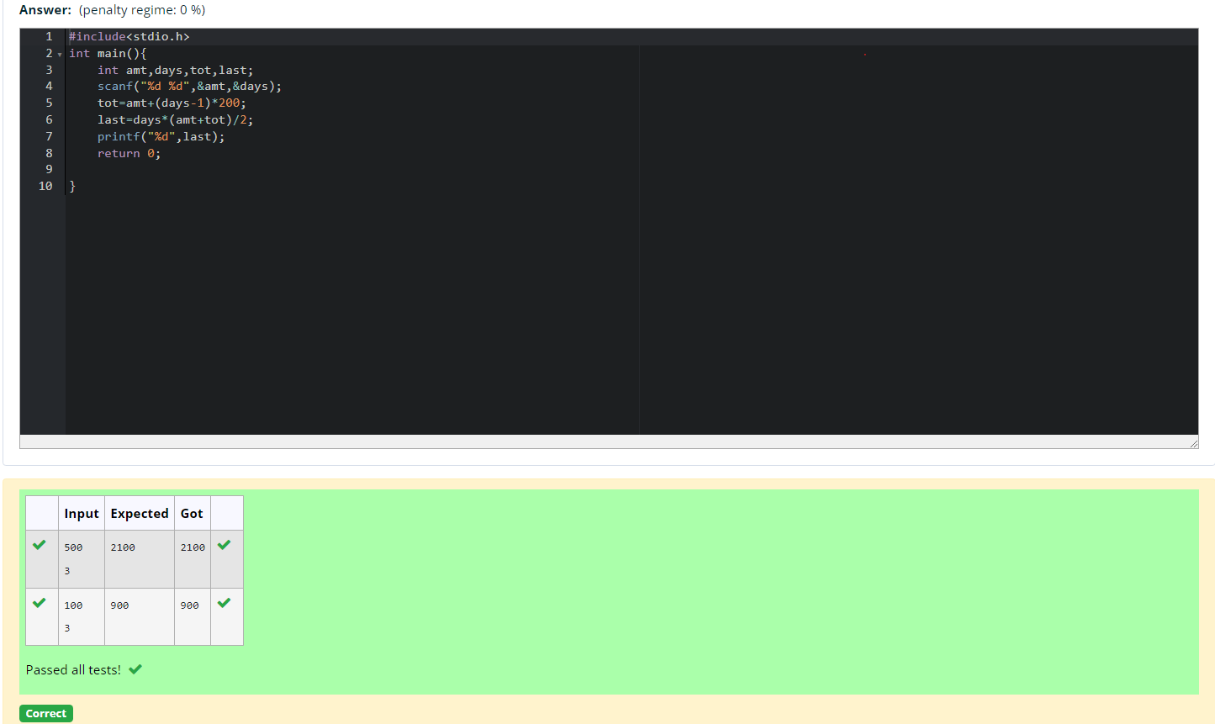

- Two numbers M and N are passed as the input. A number X is also passed as the input. The program must print the numbers divisible by X from N to M (inclusive of M and N).

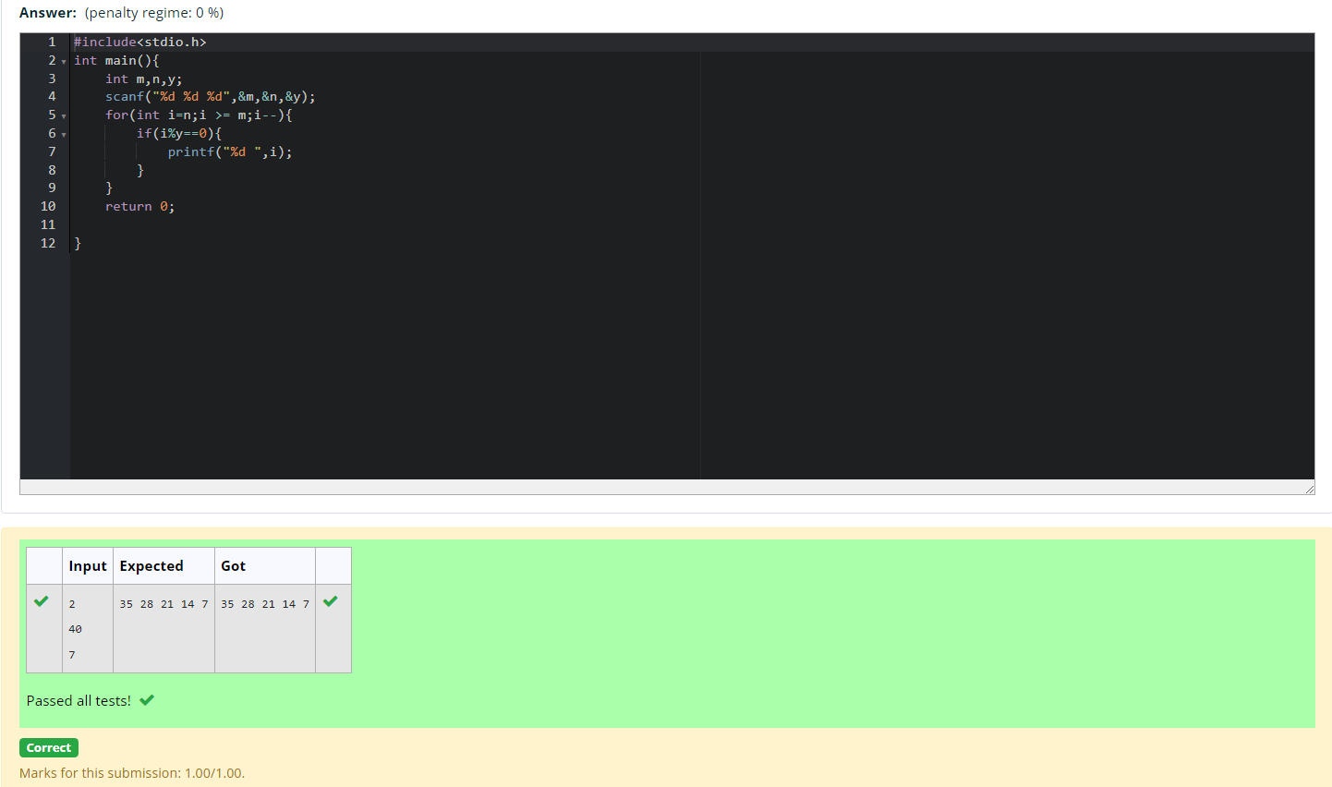

- Write a C program to find the quotient and reminder of given integers.

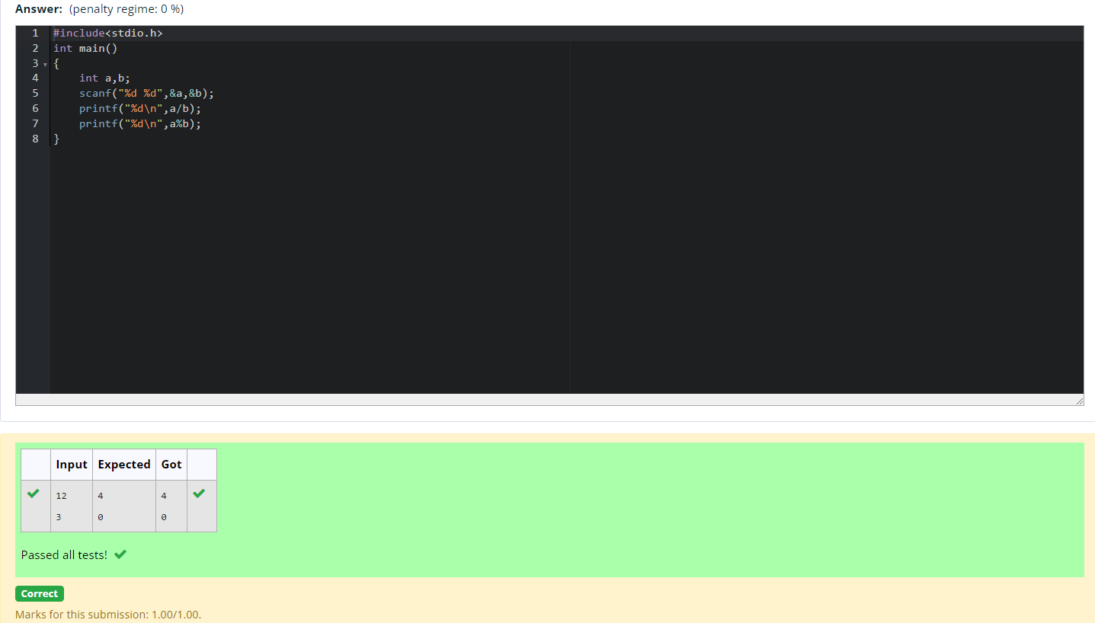

- Write a C program to find the biggest among the given 3 integers.
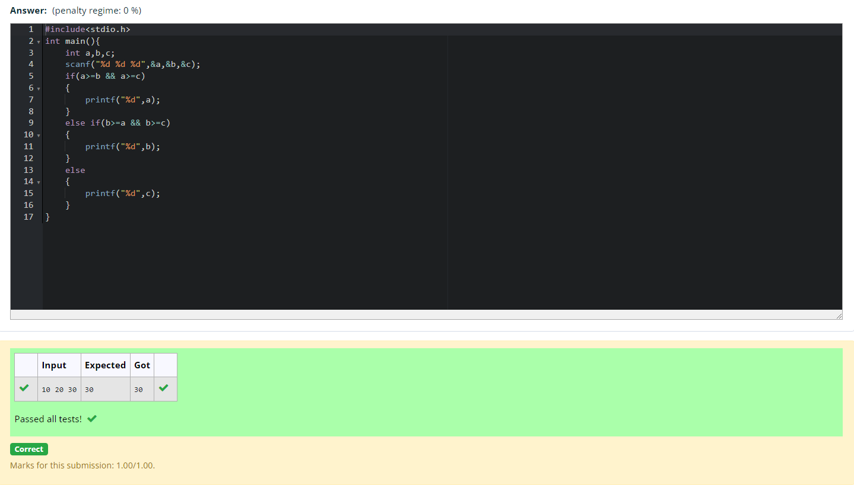

- Write a C program to find whether the given integer is odd or even.
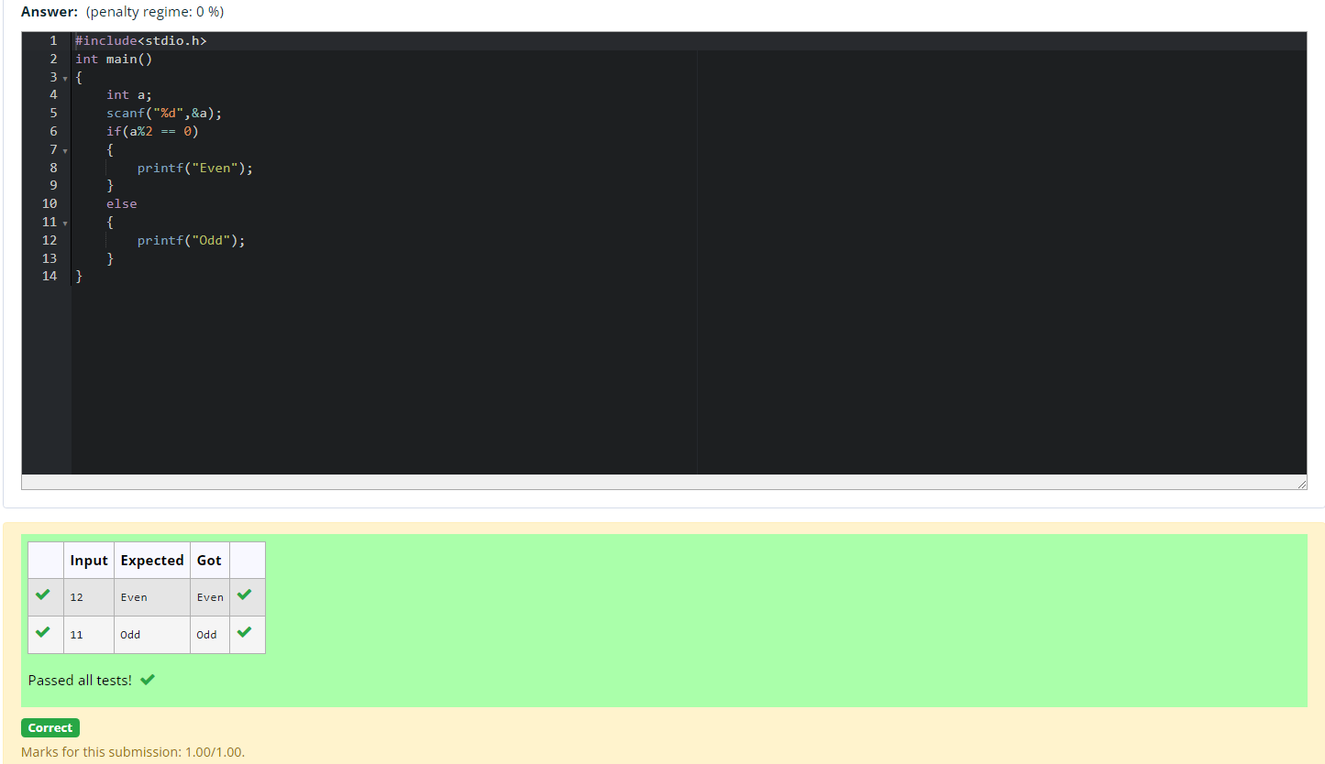

- Write a C program to find the factorial of given n.
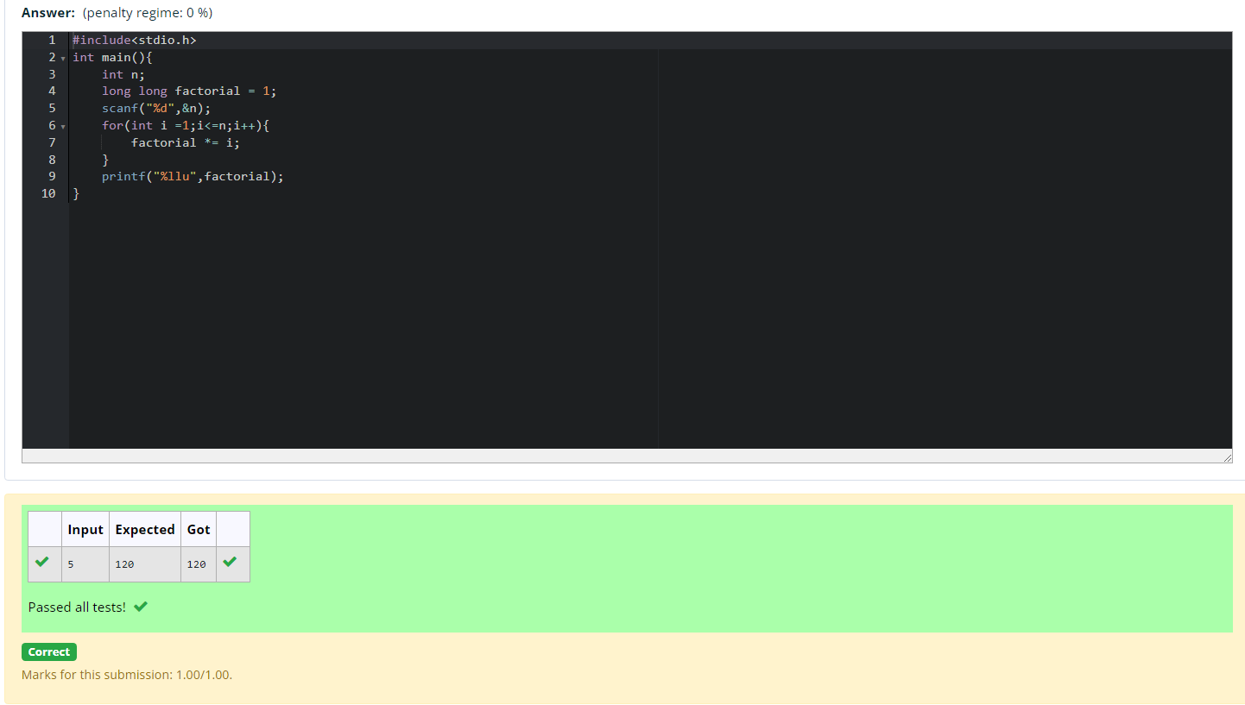

- Write a C program to find the sum first N natural numbers.
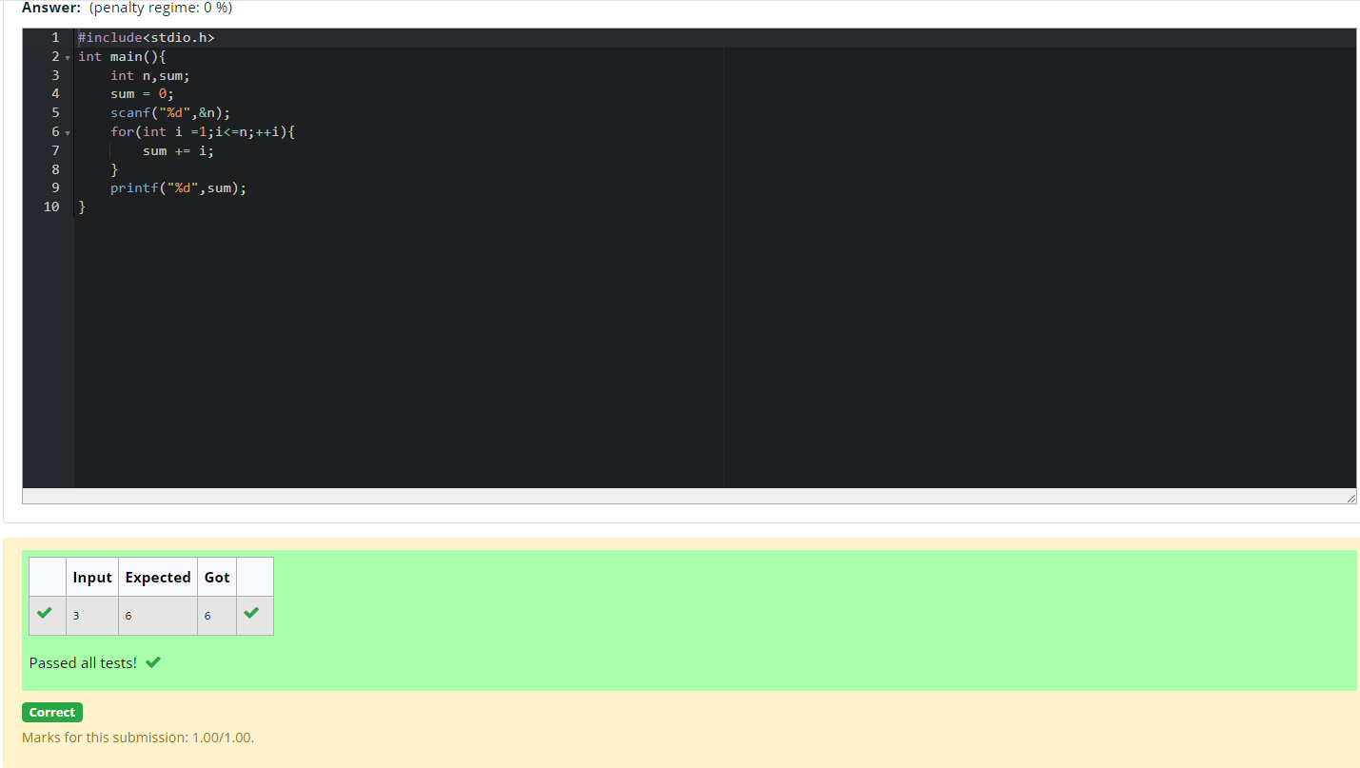

- Write a C program to find the Nth term in the fibonacci series.
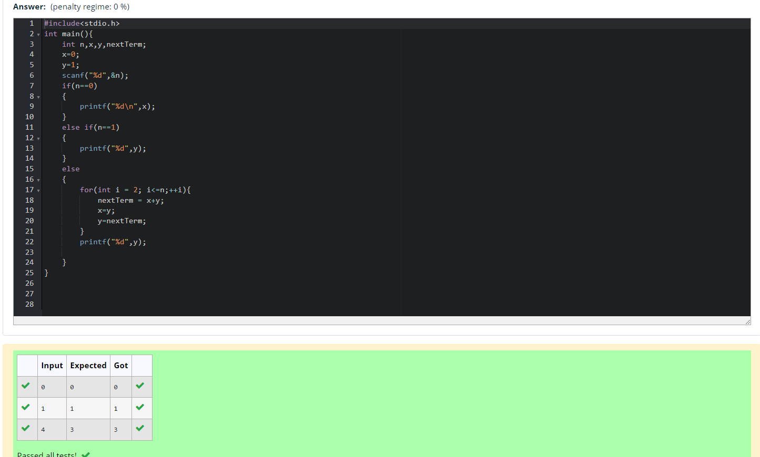

- Write a C program to find the power of integers.
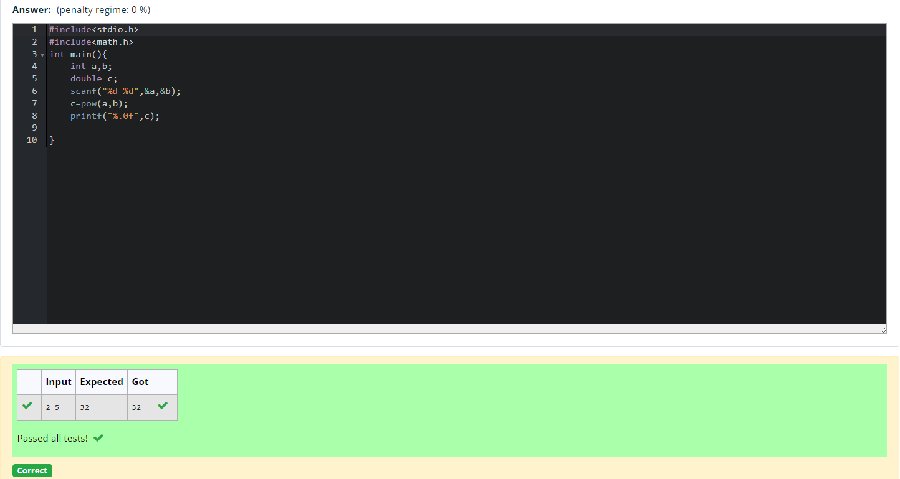

- Write a C program to find Whether the given integer is prime or not.
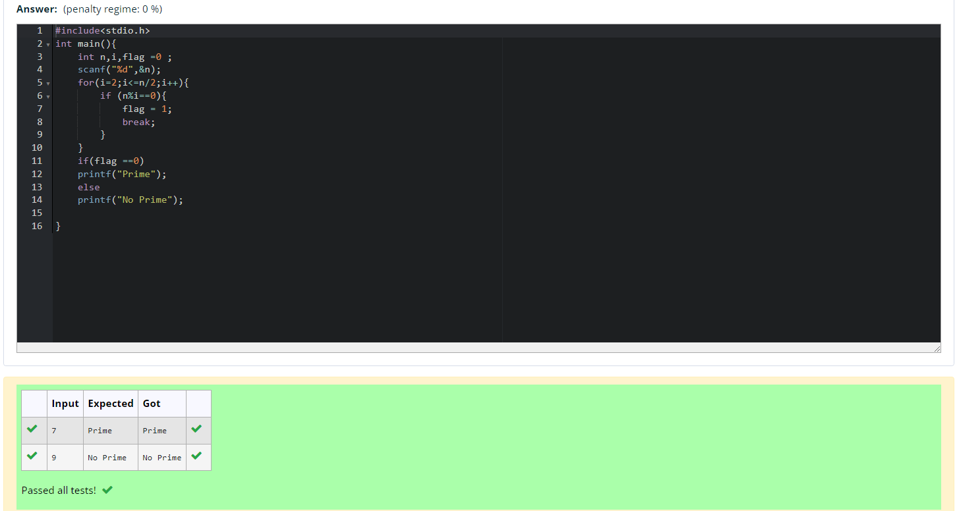

- Write a C program to find the reverse of the given integer.
